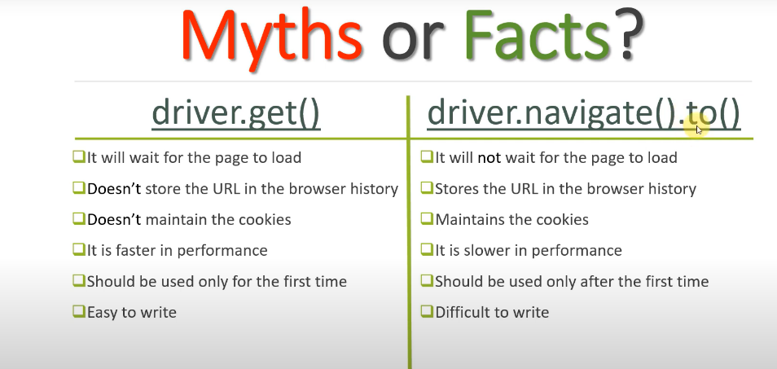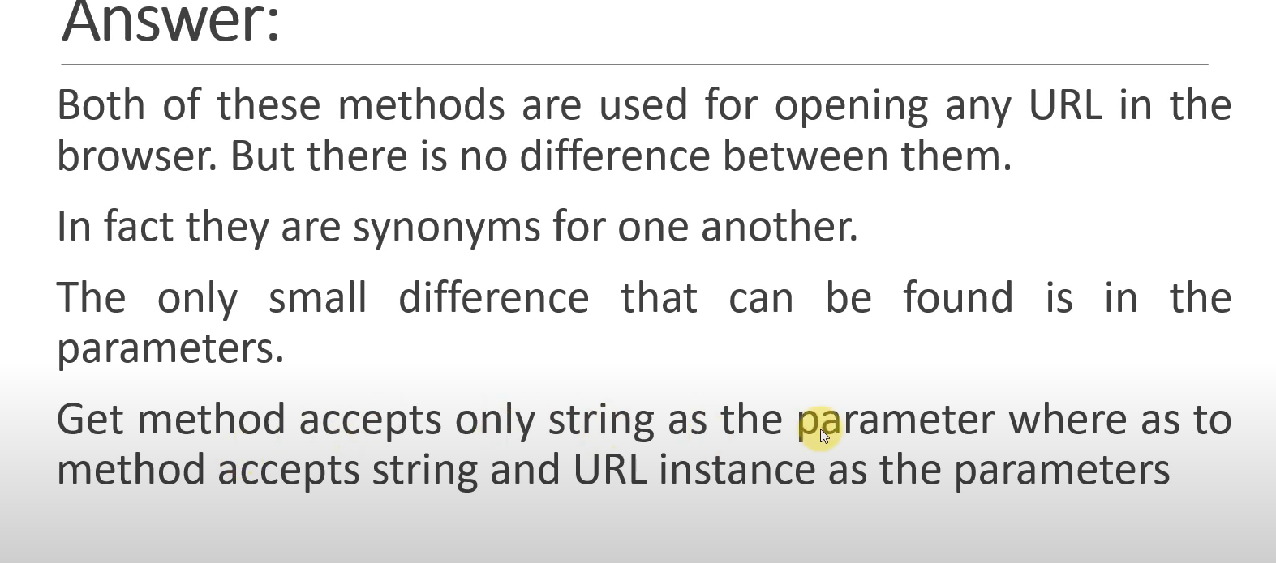

Can write remote driver also instead of WebDriver since all the implementations(methods) in interface webdriver will be available in remote webdriver claases also which is extended by the classes below

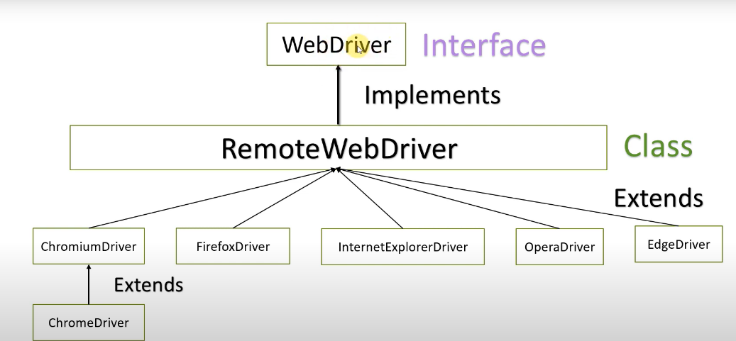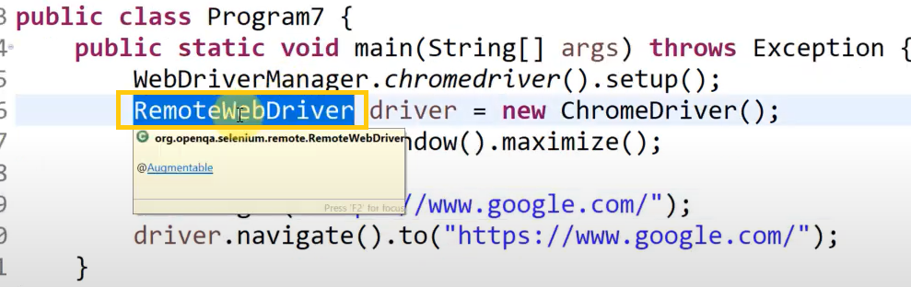

Various ways of getting classes from eclipse

* Then press cntrl+shift+T –Window open---can search for any classes or jar files
* Cntrl+that get or method name
* F3 in that particular keyword

